**COMP 3710 Artificial Intelligence**

**Fall 2016**

**Final exam**

Student Name: Student Number:

1. (17 marks) Fill in the blanks in each of the followings.
   1. A _______________ is a representation of the set of all possible choices in a given problem, one or more of which are the solution to the problem.
   2. A _______________ algorithm is an algorithm that, even for the same input, can exhibit different behaviors on different runs, as opposed to a deterministic algorithm.
   3. A _______________ is a rule or other piece of information that is used to make methods such as search more efficient or effective.
   4. An _______________ algorithm expands paths from nodes that have the lowest f-value until the algorithm visits the goal node.
   5. A _______________ problem is a combinatorial optimization problem with a set of constraints.
   6. _______________ algorithms are based on biological evolution.
   7. _______________ is a genetic operator used to vary the programming of a chromosome or chromosomes from one generation to the next.
   8. A _______________ is a sentence that is true of false but not both.
   9. An argument is _______________ if its conclusions follow logically from its premises, even if the argument does not actually reflect the real world.
   10. In Boolean logic, a formula is in _________________ if it is a conjunction of clauses, where a clause is a disjunction of literals.
   11. _______________ are designed to solve complex problems by reasoning about knowledge, represented by mainly as if-then rules.
   12. _______________ is an inference method that can be described as working backward from the goal(s).
   13. For a _______________, every value in the universe of discourse has a membership value, and so is a member to some extent.
   14. _______________ is the problem of identifying to which of a set of classes a new observation belongs, on the basis of a training set of data containing observations (or instances) whose class membership is known.
   15. _______________ is the task of grouping a set of objects in such a way that objects in the same group are more similar (in some sense or another) to each other than to those in other groups.
   16. _______________ learning learns by being presented with pre-classified training data set.
   17. _______________ behavior can appear when a number of simple entities operate in an environment, forming more complex behaviors as a collective.
2. (2 marks) Explain what an admissible heuristic is.
3. (5 marks) Fill in the blanks in each of the followings
   1. *P*(*A* ∨ *B*) = __________ + __________ - __________
   2. *P*(*A*) = *P*(*A* ∧ *B*) + __________
   3. *P*(*A* ∧ *B*) = *P*(*A*) * __________
   4. *P*(*A* | *B*) = 1 - __________
   5. *P*(*A* ∧ *B* | *C*) = __________ * __________, where *A* and *B* are conditionally independent given *C*.
4. (3 marks) Find *P*(~*cavity* | ~*toothache*) from the following joint probability table.

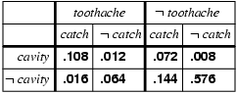

1. (3 marks) Let *M* be meningitis, *S* be stiff neck. The stiff neck is one symptom of meningitis. What is the probability of having meningitis with stiff neck, assuming the following probabilities?

*P*(*S*) = 0.2; *P*(*M*) = 0.0001; *P*(*S*|*M*) = 0.8

1. (4 marks) From the following Bayesian network, what is the probability that Mary does not call, alarm is not ringing, and there is no burglary?

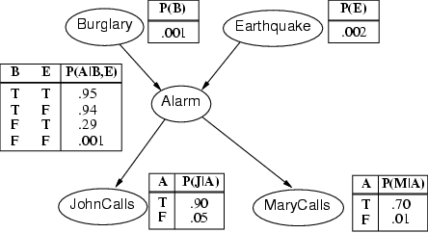

1. (4 marks) Find the class to which (3, 2, 2) belongs from the following training data. You should show how you find the class.

